**PostgreExercisesAssignment**

First I insert clubdata file:

ScreenShots:

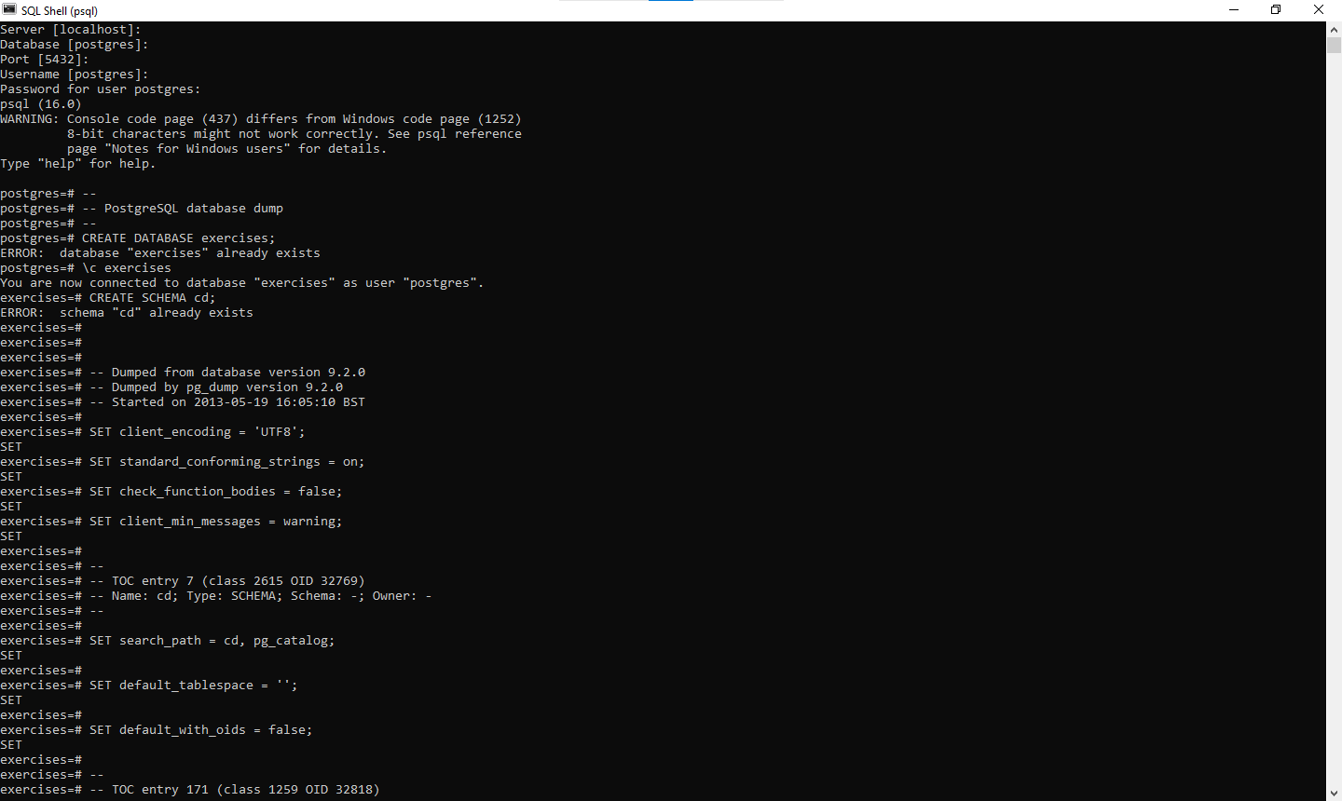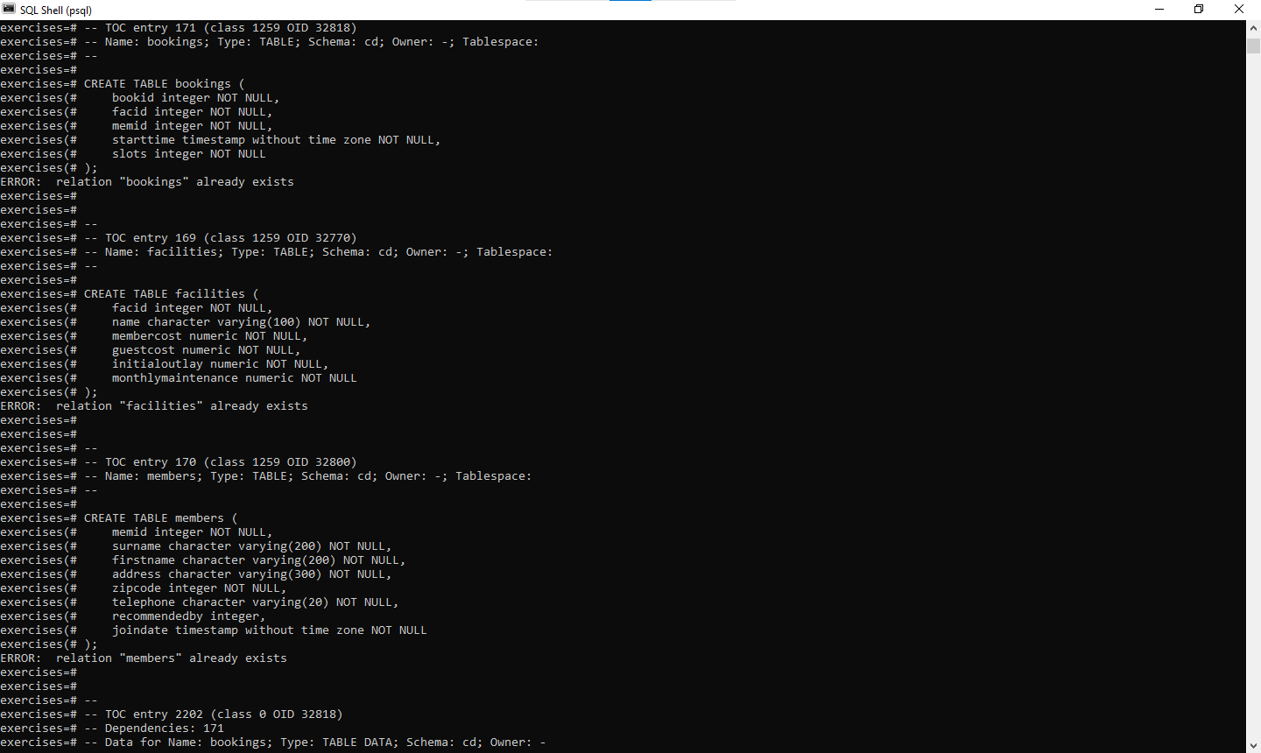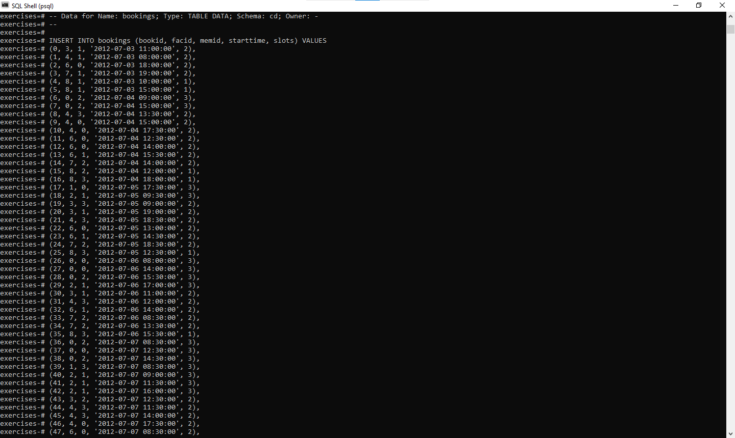

**To Choose Database Exercise:**

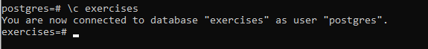

**Simple SQL Queries**

**1.**[**Retrieve everything from a table**](https://pgexercises.com/questions/basic/selectall.html)

**Query:** Select * from facilities

**SQLOUTPUT:**

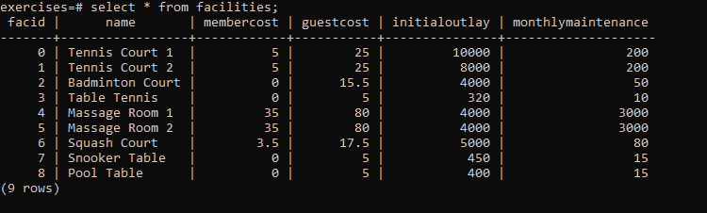

**2.**[**Retrieve specific columns from a table**](https://pgexercises.com/questions/basic/selectspecific.html)

**Query:** select name, membercost from facilities;

**SQLOUTPUT:** 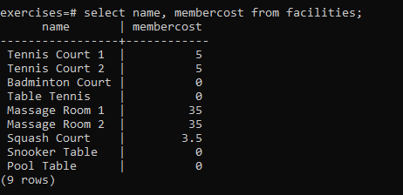

**3.**[**Control which rows are retrieved**](https://pgexercises.com/questions/basic/where.html)

**Query:** select * from facilities where membercost > 0;

**SQLOUTPUT:**

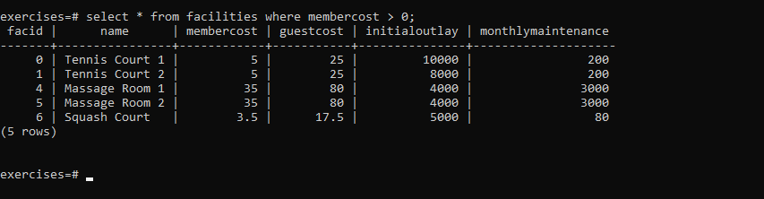

**4.**[**Control which rows are retrieved - part 2**](https://pgexercises.com/questions/basic/where2.html)

**Query:** select facid, name, membercost, monthlymaintenance from facilities where membercost > 0 and (membercost < monthlymaintenance/50.0);

**SQLOUTPUT:**

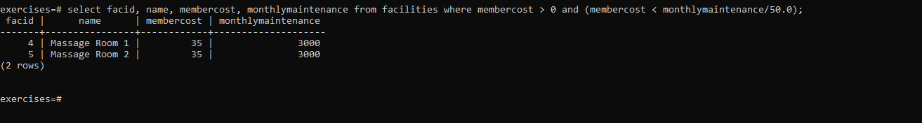

**5.**[**Basic string searches**](https://pgexercises.com/questions/basic/where3.html)

**Query:** select * from facilities where name like '%Tennis%';

**SQLOUTPUT:**

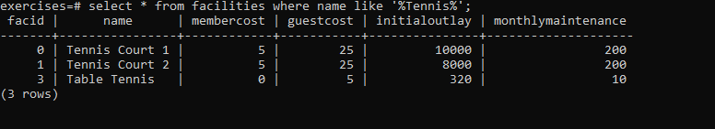

**6.**[**Matching against multiple possible values**](https://pgexercises.com/questions/basic/where4.html)

**Query:** select * from facilities where facid in (1,5);

**SQLOUTPUT:** 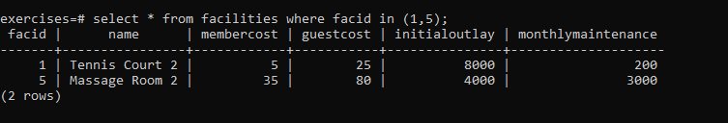

**7.**[**Classify results into buckets**](https://pgexercises.com/questions/basic/classify.html)

**Query:** select name, case when (monthlymaintenance > 100) then 'expensive' else 'cheap' end as cost from facilities;

**SQLOUTPUT:** 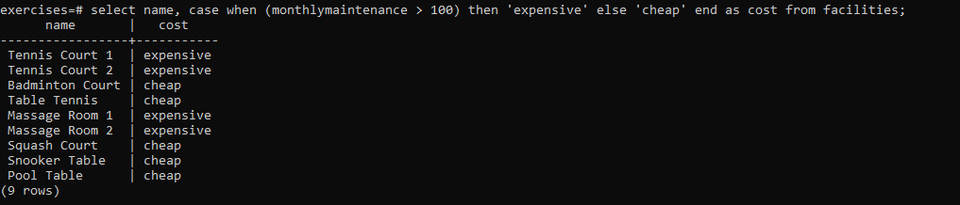

**8.**[**Working with dates**](https://pgexercises.com/questions/basic/date.html)

**Query:** select memid, surname, firstname, joindate from members where joindate >= '2012-09-01';

**SQLOUTPUT:**

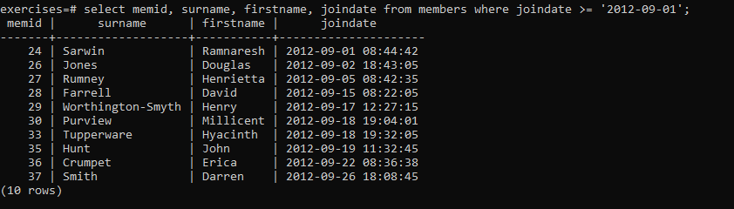

**9.**[**Removing duplicates, and ordering results**](https://pgexercises.com/questions/basic/unique.html)

**Query:** select distinct surname from members order by surname limit 10;

**SQLOUTPUT:** 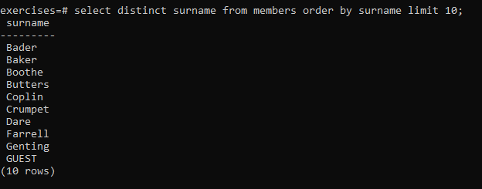

**10.**[**Combining results from multiple queries**](https://pgexercises.com/questions/basic/union.html)

**Query:** select surname from members union select name from facilities;

**SQLOUTPUT:** 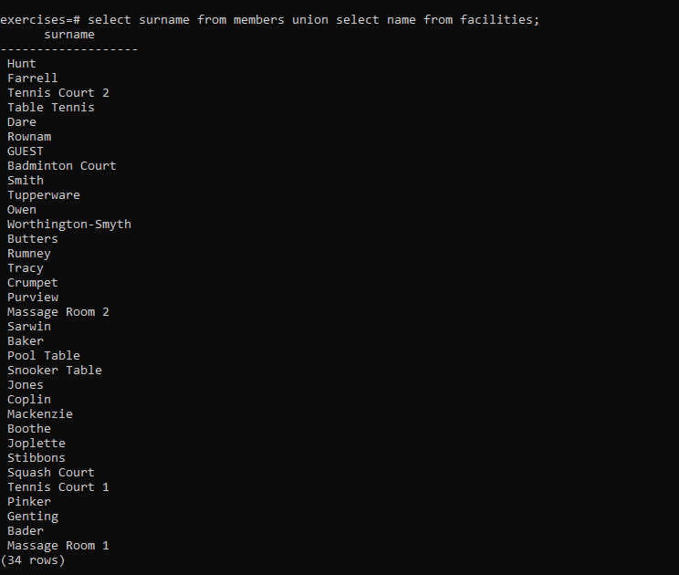

**11.**[**Simple aggregation**](https://pgexercises.com/questions/basic/agg.html)

**Query:** select max(joindate) as latest from members;

**SQLOUTPUT:** 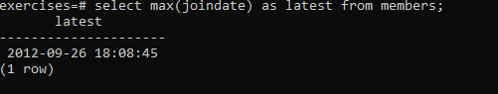

**12.**[**More aggregation**](https://pgexercises.com/questions/basic/agg2.html)

**Query:** select firstname, surname, joindate from members order by joindate desc limit 1;

**SQLOUTPUT:** 